1. INTRODUCTION
Healthcare systems generate large amounts of sensitive patient data from hospitals, clinics, and wearable devices, which are essential for disease diagnosis, personalized treatments, and real-time health monitoring. However, centralizing this data for traditional machine learning raises privacy concerns and risks non-compliance with regulations like HIPAA and GDPR. Federated Learning (FL) addresses these issues by allowing institutions to train models locally and share only model updates with a central server, keeping data on local devices and reducing privacy risks, though conventional FL can still face threats like model inversion and data leakage. To enhance security, this project introduces FRESH (Federated Ring-signature Enhanced Smart Healthcare), which combines ring signatures for anonymous client authentication, secure aggregation with differential privacy to prevent sensitive data inference, and decentralized learning to ensure regulatory compliance. This framework enables collaborative, privacy-preserving AI for disease prediction, remote monitoring, and clinical decision-making, making it ideal for smart healthcare and IoT-based environments.
1.1PURPOSE
The purpose of this project is to create a privacy-preserving federated learning framework for healthcare systems. It allows hospitals, clinics, and wearable devices to collaboratively train machine learning models while keeping sensitive patient data stored locally. This approach ensures privacy protection, supports accurate disease prediction, and enhances clinical decision-making. FRESH leverages cryptographic ring signatures for anonymous client participation and integrates secure aggregation with differential privacy to prevent data leakage. By adopting this framework, healthcare institutions can maintain trust, comply with HIPAA and GDPR, and achieve scalable, secure, and distributed AI in smart healthcare environments.
1.2SCOPE
This framework focuses on enabling secure and privacy-preserving machine learning in smart healthcare systems using Federated Learning (FL). It allows collaborative model training on distributed wearable and IoT healthcare data without exposing sensitive patient information. The system enhances privacy through ring signature authentication and secure aggregation, making it suitable for real-time healthcare applications, regulatory compliance, and protecting against source inference attacks. By ensuring privacy and security, the system supports real-time healthcare monitoring, regulatory compliance, and scalable integration across diverse medical applications, contributing to improved healthcare outcomes while maintaining strict data confidentiality.

1.3MODEL DIAGRAM:

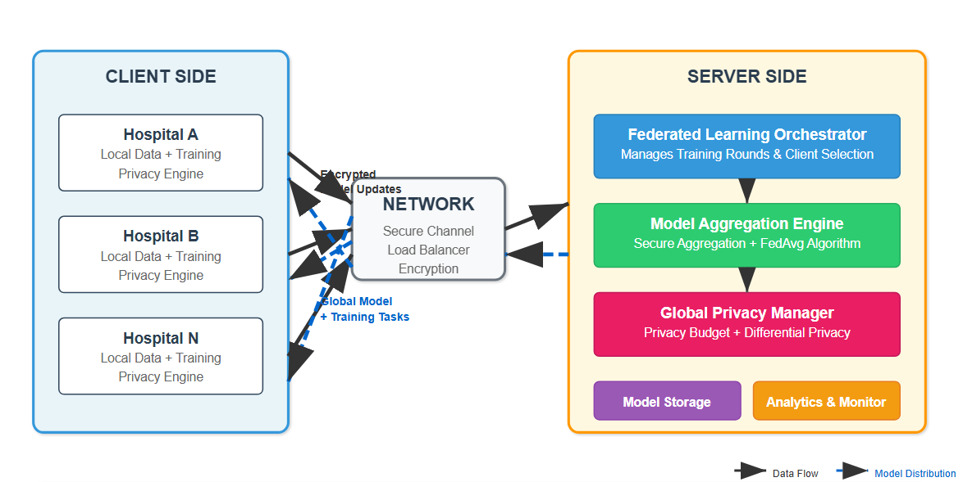

Fig-1.3: Model Diagram

2.LITERATURE SURVEY

Healthcare data is highly sensitive and requires strong privacy-preserving mechanisms for AI applications. Centralized machine learning, where patient data is collected in one location, leads to increased risks of data breaches and non-compliance with regulations like HIPAA and GDPR. Therefore, recent research emphasizes the use of federated learning (FL), cryptographic methods, and differential privacy.
Rivest, Shamir & Tauman (2001) proposed the original ring signature cryptographic scheme in their work "How to Leak the Secret". This foundational work enabled anonymous communication but had high overhead in its original version. Schnorr (1991) introduced efficient elliptic curve-based signatures for smart cards, laying the foundation for ECC signatures used in FRESH, though early versions had higher computational complexity.
Latifah et al. (2020) compared heart disease classification using logistic regression and random forests on health data. Their study showed Random Forests were effective for wearable health data but did not integrate FL or privacy-preserving techniques.
Saranya & Asha (2019) provided an overview of big data analytics in healthcare and highlighted the importance of secure data handling but lacked dedicated privacy-preserving mechanisms. Polap & Woźniak (2021) used swarm intelligence to optimize FL for medical image classification, improving accuracy but focusing mainly on imaging tasks.
For FL in healthcare AI, Yang et al. (2019) proposed decentralized training, establishing the core idea of FL for healthcare, although it lacked strong identity protection. Mothukuri et al. (2021) conducted a comprehensive survey of security and privacy in FL, emphasizing major threats and the need for defense strategies without practical implementation. Liu et al. (2021) explored gradient leakage and inference threats in FL and supported the integration of ring signatures for mitigation.

Sheller et al. (2020) demonstrated successful multi-institutional FL for medical imaging, proving FL’s viability in real-world healthcare scenarios. Nguyen et al. (2022) provided a survey of FL in smart healthcare, validating its scalability and highlighting the need for secure, complete frameworks.
The literature highlights the evolution of privacy-preserving machine learning, from early cryptographic methods like ring signatures and elliptic curve signatures to modern federated learning frameworks with secure aggregation and differential privacy.
Current smart healthcare uses wearable devices to monitor physiological data. Traditional machine learning collects data centrally, causing privacy and regulatory issues. Federated Learning (FL) lets devices train models locally without sharing raw data, improving privacy.
However, FL is still vulnerable to source inference attacks (SIAs) that can reveal user identities, and existing systems lack strong defences against these threats

3.SYSTEM ANALYSIS
3.1 EXISTING SYSTEM:
Traditional healthcare AI systems rely on centralized machine learning models. In these systems, patient data from multiple hospitals and wearable devices is transferred to a central server for training. While this approach enables data aggregation and potentially higher model accuracy, it suffers from major security and privacy concerns. Centralized storage of sensitive medical data is vulnerable to breaches, unauthorized access, and data leakage. Additionally, such systems face challenges in complying with privacy regulations like HIPAA and GDPR, as data leaves its source institution.

3.1.1 DISADVANTAGES OF EXISTING SYSTEM:
- High risk of data breaches and unauthorized access.
- Non-compliance with regulatory requirements when transferring sensitive data.
- Single point of failure in centralized storage and model training.
- Vulnerability to attacks such as model inversion or data reconstruction.

3.2 PROBLEM STATEMENT
Healthcare institutions collect large amounts of patient data, but sharing this data for collaborative machine learning poses serious privacy risks and regulatory challenges. Centralized models require transferring data to a single server, which increases the likelihood of breaches, identity exposure, and non-compliance with HIPAA and GDPR. Moreover, wearable devices and IoT sensors continuously generate real-time health data that cannot be easily shared due to bandwidth and privacy constraints. Traditional federated learning allows local training but remains vulnerable to attacks like model inversion, data leakage, and source inference attacks. Therefore, the key problem is designing a framework that enables multiple healthcare entities to collaboratively train accurate machine learning models without sharing raw patient data, while ensuring secure communication, anonymous authentication, and strong privacy guarantees through cryptographic and differential privacy techniques.
3.3 PROPOSED SYSTEM
The proposed FRESH (Federated Ring-signature Enhanced Smart Healthcare) framework is a privacy-preserving system that enables secure collaborative machine learning in healthcare. Instead of sharing raw patient data, hospitals, clinics, and wearable devices train models locally and only transmit encrypted model updates or gradients to a central server. Ring signatures are used to verify each client’s authenticity anonymously, ensuring that only trusted participants can contribute without revealing their identities. The central server aggregates the updates using secure multi-party computation and applies differential privacy to prevent data leakage or model inversion attacks. This architecture maintains HIPAA and GDPR compliance, supports both cross-silo (hospitals) and cross-device (IoT wearables) environments, and ensures scalable, secure, and reliable AI for tasks like disease prediction, patient monitoring, and clinical decision support.
3.3.1 ADVANTAGES
- It preserves data privacy by keeping patient data local, reducing risks of breaches or leaks.
- Ring signatures allow anonymous client authentication while ensuring only valid contributions.
- Secure aggregation and differential privacy protect model updates from inference or reconstruction attacks.
- The framework complies with HIPAA and GDPR, making it suitable for real healthcare applications.
- It is scalable and flexible, supporting both cross-device (wearables) and cross-silo (hospitals) environments for distributed AI in smart healthcare.

4.SYSTEM REQUIREMENT SPECIFICATION

4.1 FUNCTIONAL REQUIREMENTS
- Local Model Training: Each hospital or wearable device must train a machine learning model locally on its private dataset without transferring raw data.
- Secure Model Update Transmission: The system must securely transmit only the model parameters or gradients to the central server.
- Anonymous Authentication: Ring signatures must be implemented so that clients can authenticate themselves without revealing their identities.
- Model Aggregation: The central server must aggregate all local updates using secure aggregation techniques.
- Privacy Protection: Differential privacy must be applied to prevent leakage of sensitive patient information from model updates.
- Global Model Distribution: After aggregation, the updated global model must be distributed to all participating clients.

4.2 NON-FUNCTIONAL REQUIREMENTS
- Security: End-to-end encryption and cryptographic authentication must be used to prevent unauthorized access.
- Scalability: The system must support multiple hospitals, clinics, and IoT devices simultaneously.
- Performance: Model training and aggregation should maintain acceptable accuracy while adding minimal latency.
- Reliability: The system should handle dropped or offline clients without disrupting federated rounds.
- Regulatory Compliance: Ensure adherence to HIPAA and GDPR guidelines for healthcare data.
4.3 HARDWARE REQUIREMENTS
Minimum hardware specifications needed to deploy the system
COMPONENT | SPECIFICATION
OPERATING SYSTEM | Windows 10 / 11 or Linux (Ubuntu 20.04+)
PROCESSOR | Intel i5 / AMD Ryzen 5 or higher
RAM | 4 GB (8 GB Recommended)
HARD DISK | 250GB HDD/128 GB SSD OR higher
NETWORK | Stable and secure high-speed Internet

Table-4.3: Hardware Requirements

4.4SOFTWARE REQUIREMENTS:
The software requirements for development and execution of system include:
COMPONENT | SPECIFICATION
PROGRAMMING LANGUAGE | Python 3.x
FRAMEWORK | TensorFlow or PyTorch, PySyft for federated learning
LIBRABIES | NumPy, Pandas, Scikit-learn, Cryptography library
OPERATING SYSTEM | Windows or Linux (for both server and clients)
SECURITY TOOLS | TLS/SSL protocols for encrypted data transfer
IDE/Editor | PyCharm, VS Code, or Jupyter Notebook

Table-4.4-Software requirements

5.SYSTEM DESIGN
5.1 SYSTEM SPECIFICATION:
The FRESH framework is a client-server federated learning architecture where hospitals, clinics, and IoT devices act as local clients, and a central GPU-powered server aggregates update. Each client requires a multi-core processor, 4 GB RAM (8 GB recommended), and at least 128 GB storage, while the server requires 8–16 GB RAM, 500 GB storage, and an 8 GB VRAM GPU for secure aggregation. Both client and server can run on Windows 10/11 or Linux (Ubuntu 20.04+) and communicate through secure TLS/SSL connections. Python 3.x with TensorFlow or PyTorch, PySyft, and cryptography libraries enables privacy-preserving model training with ring signatures, secure aggregation, and differential privacy.

5.2 MODULES:
1. Data Preprocessing Module
- Cleans and normalizes patient data on each client (hospital or wearable device).
- Handles missing values, data formatting, and feature extraction locally.
2. Local Model Training Module
- Trains machine learning or deep learning models on local datasets.
- Supports batch training and periodic updates for federated learning rounds.
3.Secure Communication & Encryption Module
- Manages encrypted transmission of model updates using TLS/SSL.
- Implements ring signature generation for anonymous client authentication.
4.Federated Aggregation Module
- Collects local updates from multiple clients.
- Uses FedAvg algorithm with secure multi-party computation and differential privacy for model aggregation.
5. Client Selection & Coordination Module
- Determines which clients participate in each training round.
- Ensures load balancing and handles offline or slow devices.
6.Global Model Distribution Module
- Sends the aggregated global model back to clients for the next training round.
- Maintains version control of models and logs updates for monitoring.
7.Monitoring and Logging Module
- Tracks system performance, training progress, and communication security.
- Logs anomalies or failed updates for audit and compliance.

5.3 ALGORITHMS
The FRESH framework relies on the following algorithms for secure federated learning:
- Federated Averaging (FedAvg) – Aggregates locally trained model weights on the central server to form a global model.
- Ring Signature – Authenticates client updates anonymously, ensuring only valid contributions without revealing identities.
- Secure Aggregation – Encrypts individual model updates and combines them so the server sees only the aggregated result.
- Differential Privacy – Adds controlled noise to model updates before transmission to protect against inference and model inversion attacks.

5.4 DATAFLOW DIAGRAM
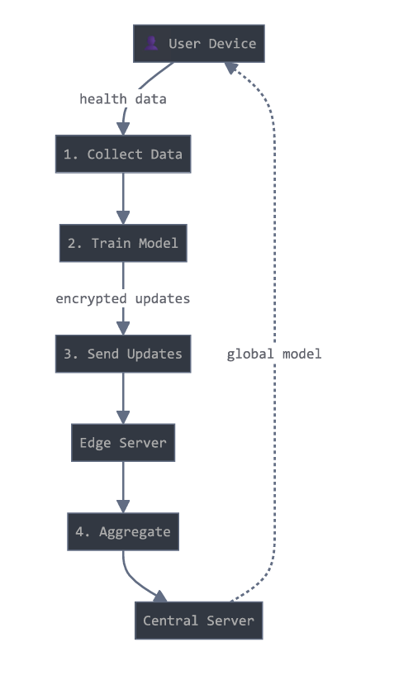
Fig-5.4- Dataflow Diagram
5.5 UML DIAGRAMS
UML stands for Unified Modeling Language. The goal is for UML to become a Common Language for Creating Models of Object-oriented computer software.

5.5.1 USECASE DIAGRAM
Use case diagrams consists of actors, use cases and their relationships. The diagram is used to model the system/subsystem of an application. The purpose of use case diagram is to capture the dynamic aspect of a system.
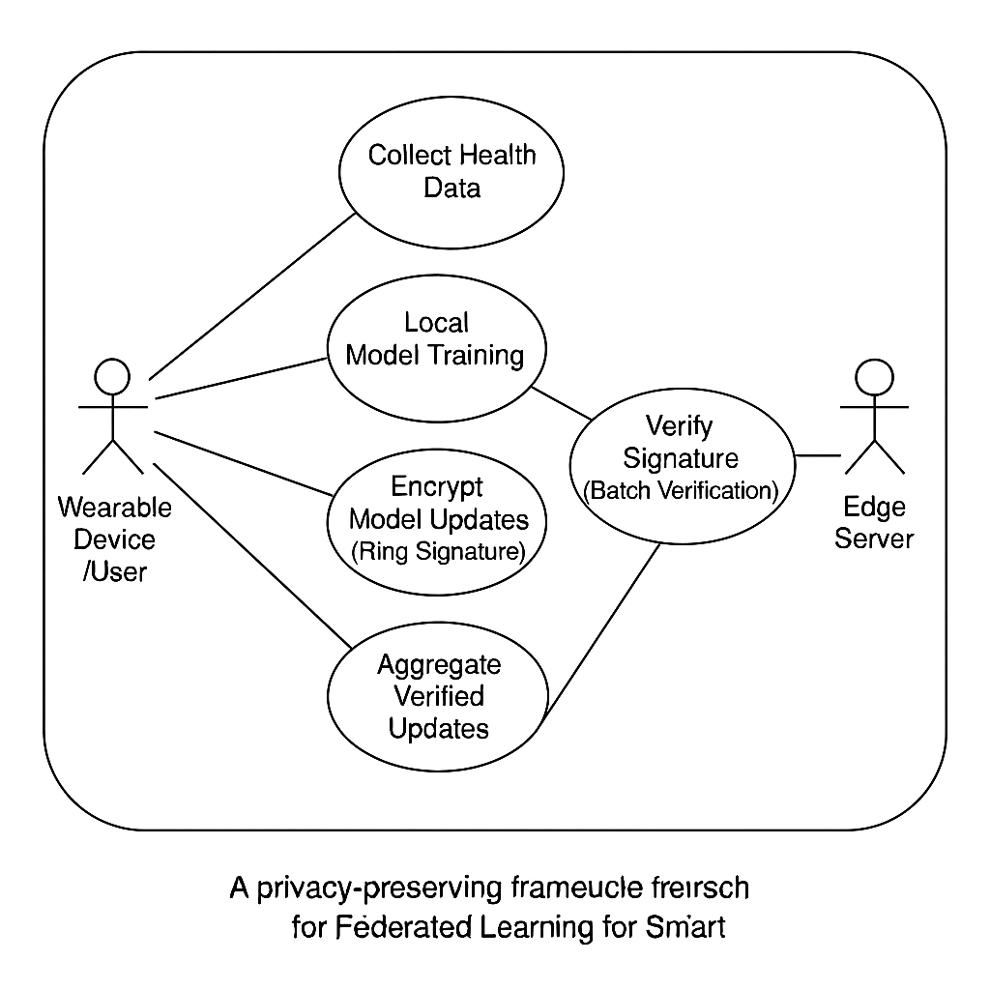5.5.1: Use case diagram

5.5.2 CLASS DIAGRAM

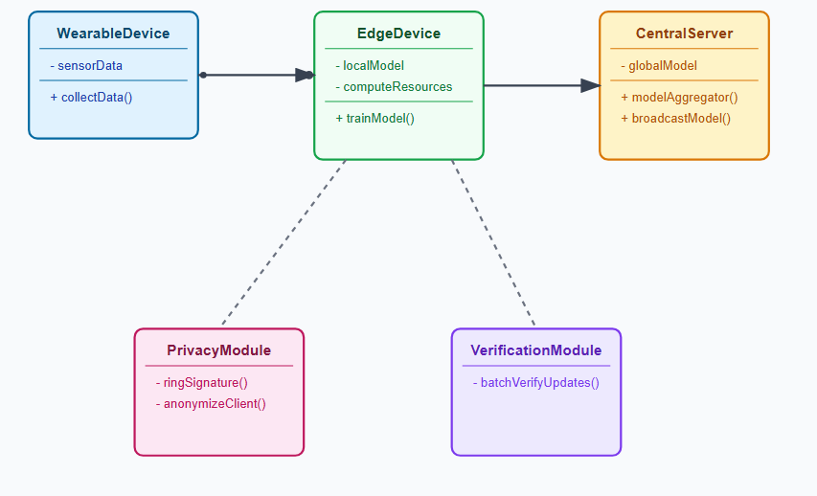 Fig:5.5.2-Class Diagram

5.5.3 SEQUENCE DIAGRAM
Sequence diagram emphasizes on time sequence of messages. Sequence diagram are used to capture the dynamic nature but from a different angle. The purpose of is to capture the dynamic behavior of a system.
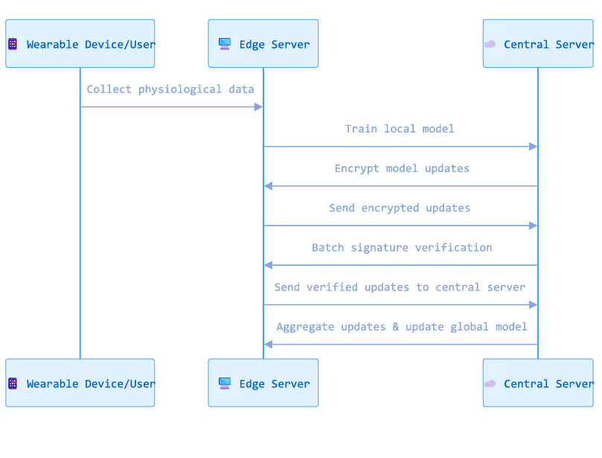
Fig:5.5.3-Sequence Diagram

5.5.4 ER DIAGRAM
An ER (Entity-Relationship) Diagram is used to visually represent the entities, their attributes, and relationships in the FRESH framework. It helps in understanding the secure data flow, designing the database structure, and ensuring privacy-preserving federated learning.
Entities:
Hospital/Clinic, Wearable Device, Central Server, User/Patient, and Model Update.

  - Attributes:
Hospital/Clinic: Hospital ID, Name, Location, Local Model
Wearable Device: Device ID, Patient ID, Sensor Data, Timestamp
User/Patient: Patient ID, Name, Age, Health Data
Model Update: Update ID, Model Weights, Signature, Round Number
Central Server: ServerID, Aggregated Model, Training Round
- Relationships – Users provide data via devices, hospitals train locally, and the central server aggregates encrypted updates.
- Keys – Patient ID is the primary key for users and foreign key in devices; Update ID is the primary key for model updates linked to HospitalID or DeviceID.
- Purpose – Represents secure data flow and relationships among entities for privacy-preserving federated learning.

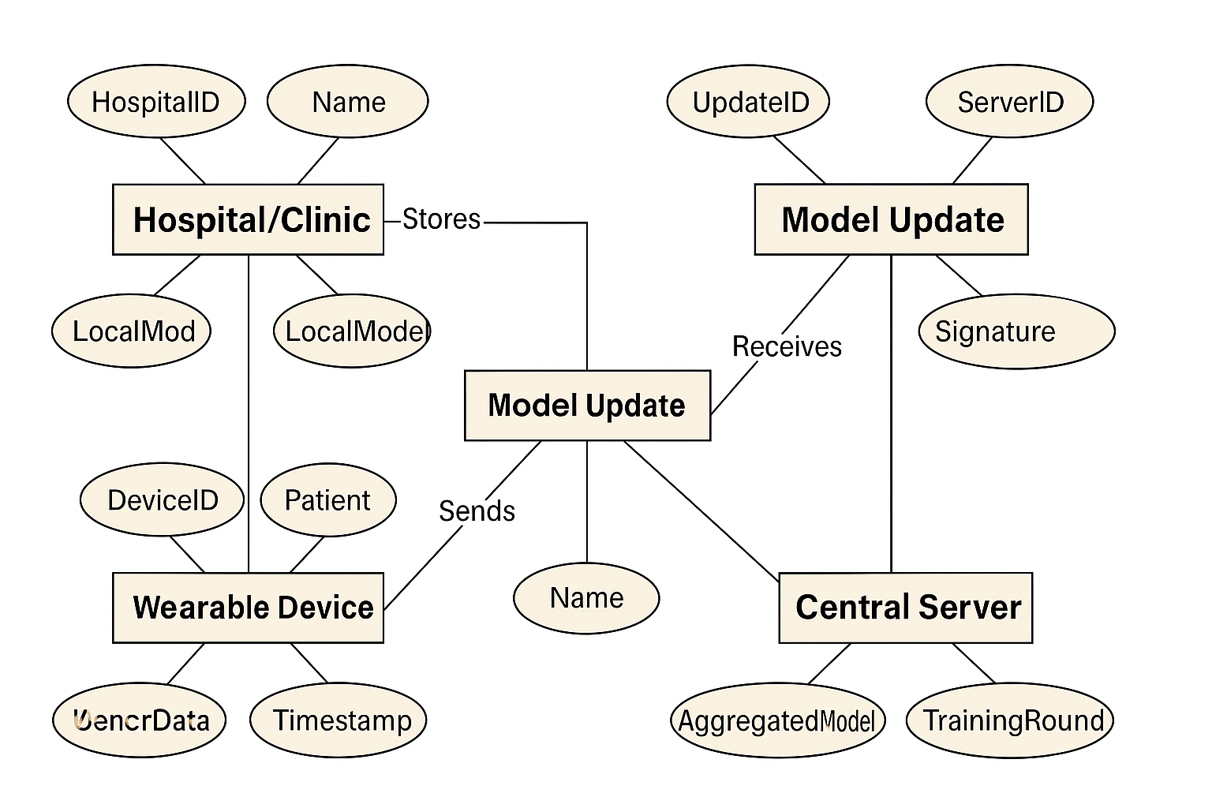
Fig-5.5.4-ER Diagram

5.5.5 COMPONENT DIAGRAM
Component diagrams are used to visualize the organization and relationships among components in a system. These diagrams are also used to make executable systems.
The component diagram shows the major software components and their interactions:

Mobile Application & Edge Device
- Mobile Application: The user's starting point.
- Edge Device Module: The software on the phone that handles everything locally. It collects data and verifies it.
Local Learning & Privacy
- Local Training Model: A small, personalized model is trained directly on the phone using the collected data.
- Model Packaging: The local model is prepared for secure transmission.
- Privacy Modules: Two components (Privacy MVL and Privacy Module) apply privacy filters to the model.
- Ring Signature Auth: A cryptographic tool used by the privacy modules to make the model anonymous and verify it without revealing its origin.
Central Server & Aggregation
- Central Aggregator: The main server that receives the anonymized models.
- Global Model Update: The central server combines all the private, local models into one powerful global model.
- Verification: The server performs a final check on the data/models.

5.5.6 ACTIVITY DIAGRAM
Activity diagram is basically a flowchart to represent the flow from one activity to another activity. The activity can be described as an operation of the system. The control flow is drawn from one operation to another. This flow can be sequential, branched, or concurrent. It captures the dynamic behavior of the system.
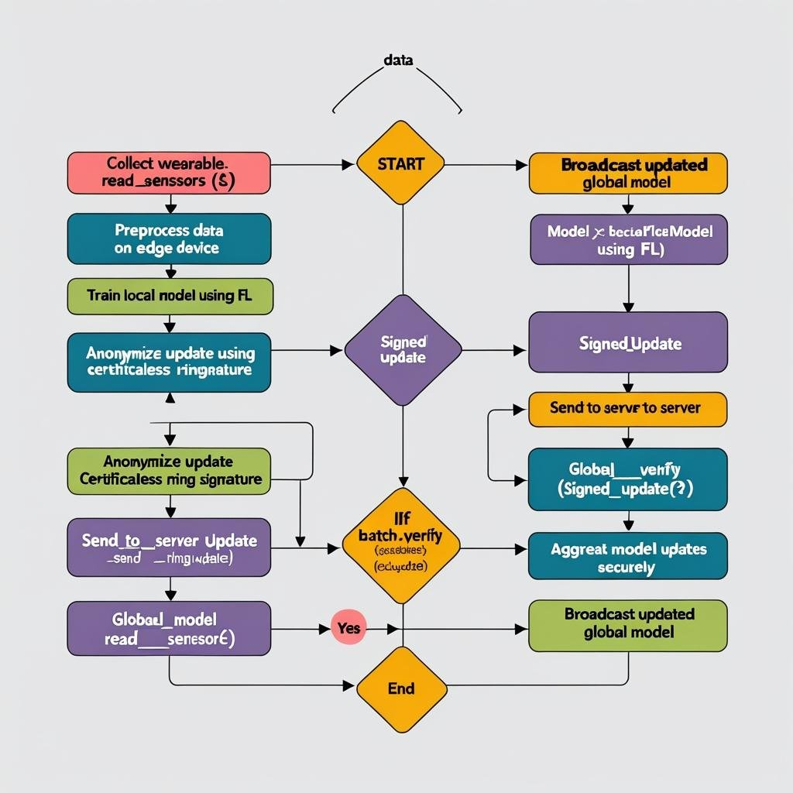
Fig-5.5.6-Activity Diagram

5.5.7 Deployment Diagram
Deployment diagrams are used to visualize the topology of the physical components of a system, where the software components are deployed. Deployment diagrams are used to describe the static deployment view of a system. Deployment. The purpose of deployment diagram visualizes the hardware topology of a system.

1.Patient Smartphone
- Function: Used by the patient for registration and authentication. It collects health data like heart rate and steps.
Edge Device
- Function: The smartphone itself, acting locally. It protects data by encrypting it and trains small models on the device.

2.Cloud Server
- Function: The central hub. It verifies data coming from devices and combines all the small local models to create one improved global model.
3.Global Database
- Function: The main storage system. It stores the final global model and provides backup and recovery services for all data.

6.IMPLEMENTATION
We extended the base model by applying a Stacking Classifier combining Decision Tree, Random Forest, and LightGBM, improving prediction accuracy across datasets. The system is also integrated into a Flask-based front end, offering user authentication for secure testing and usage.
6.1 SAMPLE CODE
class HealthcareDataSimulator:
"""Simulates healthcare data from IoT devices and wearables"""
def __init__(self, num_features: int = 20, num_classes: int = 5):
self.num_features = num_features
self.num_classes = num_classes
self.feature_names = [
'heart_rate', 'blood_pressure_sys', 'blood_pressure_dia', 'temperature',
'oxygen_saturation', 'glucose_level', 'steps_count', 'sleep_hours',
'stress_level', 'activity_level', 'bmi', 'age', 'exercise_duration',
'water_intake', 'calorie_intake', 'medication_adherence', 'pain_level',
'mood_score', 'respiratory_rate', 'weight'
]
def generate_synthetic_data(self, num_samples: int, class_distribution: Optional[List[float]] = None) -> Tuple[torch.Tensor, torch.Tensor]:
"""Generate synthetic healthcare data"""
if class_distribution is None:
class_distribution = [0.4, 0.15, 0.15, 0.15, 0.15]

labels = np.random.choice(self.num_classes, size=num_samples, p=class_distribution)
features = np.zeros((num_samples, self.num_features))

for i in range(num_samples):
label = labels[i]
if label == 0: # Healthy
features[i] = self._generate_healthy_profile()
elif label == 1: # Diabetes
features[i] = self._generate_diabetes_profile()
elif label == 2: # Hypertension
features[i] = self._generate_hypertension_profile()
elif label == 3: # Heart Disease
features[i] = self._generate_heart_disease_profile()
elif label == 4: # Respiratory Issues
features[i] = self._generate_respiratory_profile()

scaler = StandardScaler()
features = scaler.fit_transform(features)

return torch.FloatTensor(features), torch.LongTensor(labels)

def _generate_healthy_profile(self) -> np.ndarray:
"""Generate healthy patient profile"""
return np.array([
np.random.normal(75, 10), np.random.normal(120, 10), np.random.normal(80, 5),
np.random.normal(98.6, 0.5), np.random.normal(98, 1), np.random.normal(90, 10),
np.random.normal(8000, 2000), np.random.normal(8, 1), np.random.normal(3, 1),
np.random.normal(7, 1), np.random.normal(23, 3), np.random.normal(35, 15),
np.random.normal(45, 15), np.random.normal(2.5, 0.5), np.random.normal(2000, 300),
np.random.normal(9, 1), np.random.normal(2, 1), np.random.normal(8, 1),
np.random.normal(16, 2), np.random.normal(70, 15)
])

def _generate_diabetes_profile(self) -> np.ndarray:
"""Generate diabetes patient profile"""
profile = self._generate_healthy_profile()
profile[4] = np.random.normal(150, 30)
profile[10] = np.random.normal(28, 4)
profile[14] = np.random.normal(1800, 200)
return profile

def _generate_hypertension_profile(self) -> np.ndarray:
"""Generate hypertension patient profile"""
profile = self._generate_healthy_profile()
profile[1] = np.random.normal(150, 15)
profile[2] = np.random.normal(95, 8)
profile[8] = np.random.normal(6, 1)
return profile

def _generate_heart_disease_profile(self) -> np.ndarray:
"""Generate heart disease patient profile"""
profile = self._generate_healthy_profile()
profile[0] = np.random.normal(85, 15)
profile[1] = np.random.normal(140, 20)
profile[9] = np.random.normal(4, 1)
profile[16] = np.random.normal(4, 1)
return profile

def _generate_respiratory_profile(self) -> np.ndarray:
"""Generate respiratory issues profile"""
profile = self._generate_healthy_profile()
profile[4] = np.random.normal(94, 3)
profile[18] = np.random.normal(20, 3)
profile[9] = np.random.normal(5, 1)
return profile

def create_federated_datasets(self, num_clients: int, samples_per_client: int,
heterogeneity: float = 0.5) -> List[Tuple[torch.Tensor, torch.Tensor]]:
"""Create heterogeneous datasets for federated learning clients"""
client_datasets = []

for i in range(num_clients):
base_distribution = [0.4, 0.15, 0.15, 0.15, 0.15]

if heterogeneity > 0:
specialty_class = i % self.num_classes
skewed_distribution = base_distribution.copy()
skewed_distribution[specialty_class] += heterogeneity * 0.3

for j in range(self.num_classes):
if j != specialty_class:
skewed_distribution[j] *= (1 - heterogeneity * 0.3 / (self.num_classes - 1))

total = sum(skewed_distribution)
skewed_distribution = [d / total for d in skewed_distribution]
else:
skewed_distribution = base_distribution

client_data = self.generate_synthetic_data(samples_per_client, skewed_distribution)
client_datasets.append(client_data)

return client_datasets

def run_federated_experiment():
"""Run the federated learning experiment"""
global experiment_results, training_metrics, server_instance, clients_instance

device = torch.device('cuda' if torch.cuda.is_available() else 'cpu')

# Configuration
num_clients = 5
samples_per_client = 1000
num_features = 20
num_classes = 5
federated_rounds = 10
local_epochs = 3

# Initialize components
data_simulator = HealthcareDataSimulator(num_features, num_classes)
client_datasets = data_simulator.create_federated_datasets(
num_clients=num_clients,
samples_per_client=samples_per_client,
heterogeneity=0.7
)

test_data = data_simulator.generate_synthetic_data(500)
dp_mechanism = DifferentialPrivacyMechanism(epsilon=1.0, delta=1e-5)
global_model = HealthcareNeuralNetwork(num_features, [128, 64, 32], num_classes)
secure_aggregator = SecureAggregation(noise_scale=0.05)
fl_server = FederatedHealthcareServer(global_model, secure_aggregator, device)

# Create clients
clients = []
for i in range(num_clients):
client_model = HealthcareNeuralNetwork(num_features, [128, 64, 32], num_classes)
client = HealthcareClient(i, client_model, client_datasets[i], dp_mechanism, device)
clients.append(client)
fl_server.register_client(client)

# Training loop
training_metrics = []
for round_num in range(federated_rounds):
selected_clients = random.sample(clients, k=min(3, len(clients)))
round_stats = fl_server.federated_training_round(selected_clients, local_epochs)
eval_results = fl_server.evaluate_global_model(test_data)

combined_metrics = {**round_stats, **eval_results, 'round': round_num + 1}
training_metrics.append(combined_metrics)

# Store results
server_instance = fl_server
clients_instance = clients

final_accuracy = training_metrics[-1]['accuracy']
final_privacy_budget = training_metrics[-1]['privacy_budget_used']

experiment_results = {
'final_accuracy': final_accuracy,
'final_privacy_budget': final_privacy_budget,
'total_rounds': federated_rounds,
'num_clients': num_clients,
'device': str(device),
'dp_epsilon': dp_mechanism.epsilon,
'dp_delta': dp_mechanism.delta,
'completed': True,
'timestamp': datetime.now().strftime('%Y-%m-%d %H:%M:%S')
}

return experiment_results

6.2. EVALUATION METRICS
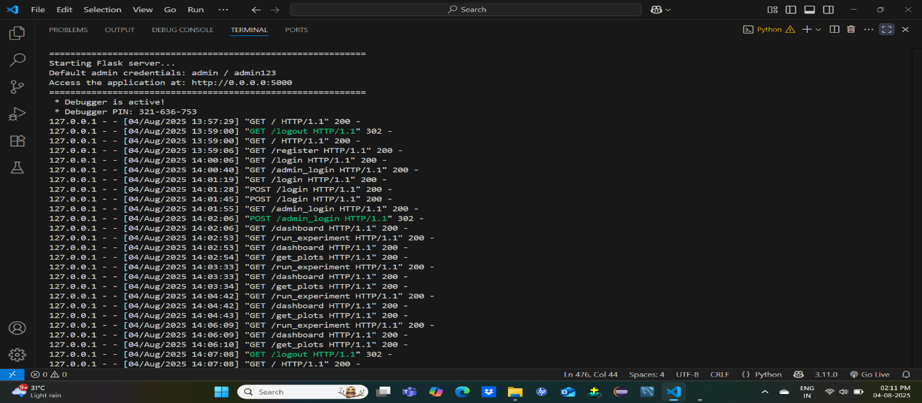
Fig-6.2-Evaluation Metrics
6.3 Software:
Layer | Technology
Frontend | Matplotlib/Seaborn
Backend | Python 3.x, Flask Web Framework, pyTorch, NumPy, Scikit-learn
Database/Storage | SQLite / CSV / JSON (Lightweight storage)
ML Model | scikit-learn (Random Forest Classifier)
Data Handling | NumPy + scikit-learn + PyTorch Tensors
IDE/Tools | VS Code / PyCharm / JupyterLab
Browser | Google Chrome, Firefox
Fig-6.3-Software

7.SYSTEM TESTING
System testing is a high-level testing process where the complete and fully integrated system is tested as a whole to verify that it meets the specified requirements. It evaluates the functional and non-functional aspects of the system, including performance, security, usability, and reliability.
7.1 TESTING STRATEGIES
The following testing strategies were applied.
1. Functional Testing
- Verify end-to-end operations: data collection, local training, secure update transmission, and global model aggregation.
2. Integration Testing
- Ensure smooth interaction between wearable devices, client nodes, and the central aggregation server.
3. Performance Testing
- Measure training time, network latency, and system behavior under high load.
4. Security & Privacy Testing
- Validate ring signatures, secure aggregation, and resistance to privacy attacks.
5.Reliability & Recovery Testing
- Check system recovery from client dropouts, network failures, and server restarts.
6.Usability & Monitoring Testing
- Ensure clear logs, alerts, and dashboards for monitoring system health.

7.2 TEST CASES:
Field | Value
Test Case ID | TC01
Scenario | New client with valid ring signature
Input Details | Client metadata with ring signature
Preprocessing | Signature validation
Models Trained | None
Expected Output | ✅Ring signature verified
Actual Output | Client added
Result | ✅Success - Ssignature time ≤ threshold
Remarks | Validates secure client onboarding

Field | Value
Test Case ID | TC02
Scenario | Local Model Training
Input Details | Health data + global weights
Preprocessing | Normalization
Models trained | Neural Network
Expected Output | Local model updated
Actual Output | Gradients securely sent
Result | ✅Success-Batch time < verifying one by one
Remarks | Core FL functionality Tested

Field | Value
Test Case ID | TC03
Scenario | Source Inference Attack Simulation
Input Details | Simulated gradient updates
Preprocessing | Not applicable
Models Trained | Federated model
Expected Output | No identity information leakage
Actual Output | Privacy preserved
Result | ✅Success-Linear/sub-linear growth with clients
Remarks | Confirms privacy preservation

Field | Value
Test Case ID | TC04
Scenario | Malicious Client Detection
Input Details | Tampered model update
Preprocessing | Gradient validation
Models trained | FedAvg model
Expected Output | Detect anomaly and reject update
Actual Output | Update rejected
Result | ✅Success-Client identity protected
Remarks | Ensures model robustness

Field | Value
Test Case ID | TC05
Scenario | Scalability with Multiple Clients
Input Details | 10+ client health datasets
Preprocessing | Client batching
Models Trained | Federated averaging
Expected Output | Handle multiple updates without failure
Actual Output | Model consistent
Result | ✅Success -Accuracy not degraded due to privacy
Remarks | Demonstrates scalability

Field | Value
Test Case ID | TC06
Scenario | Global Model Aggregation (FedAvg)
Input Details | Gradient updates from clients
Preprocessing | Secure aggregation
Models trained | FedAvg
Expected Output | Correct aggregation of client updates
Actual Output | Global model aggregated
Result | ✅Success -System performs efficiently under load
Remarks | Ensures correctness of FL aggregation

Field | Value
Test Case ID | TC07
Scenario | Final Prediction at Client Side
Input Details | Patient symptom/test data
Preprocessing | Feature scaling
Models Trained | Trained federated model
Expected Output | Accurate mental health prediction
Actual Output | Prediction generated
Result | ✅Success -No raw data leakage, aggregation correct
Remarks | Privacy-preserving personalized care

7.3 Results and Discussion:
For future work, advanced feature selection techniques such as genetic algorithms or bat search algorithms could be explored to enhance the robustness of the proposed model. Additionally, incorporating nested ensemble techniques using methods like bagging and boosting may further improve the reliability of predictions. These advancements would contribute to the ongoing evolution of software defect prediction models, enhancing their effectiveness and applicability in real-world software development environments.

SCREENSHOTS:
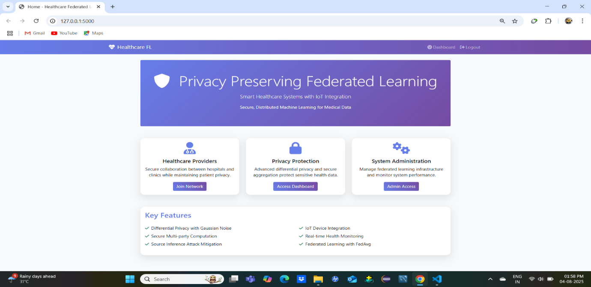
Fig:7.3.1-Home page
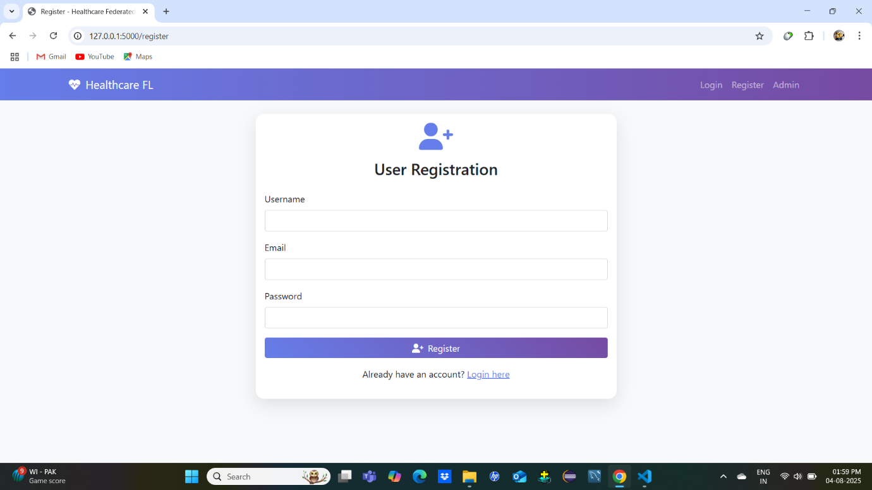
Fig:7.3.2-User Registration

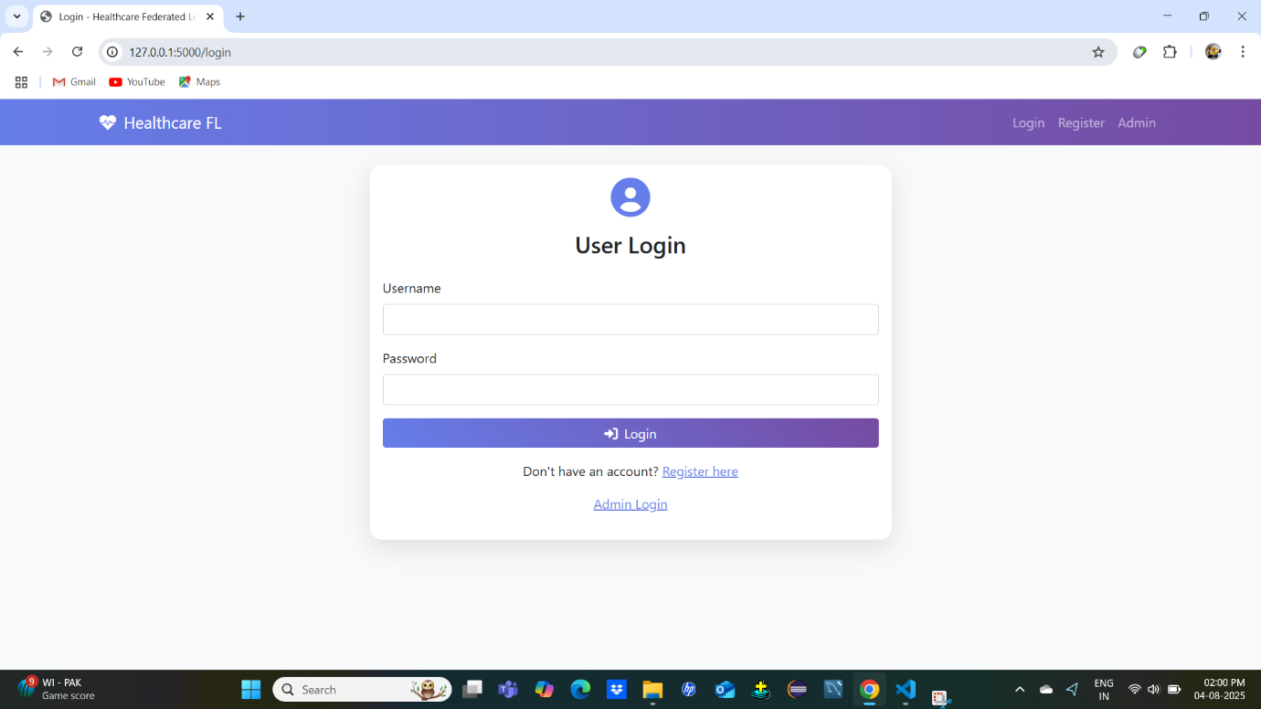
Fig:7.3.3-User Login

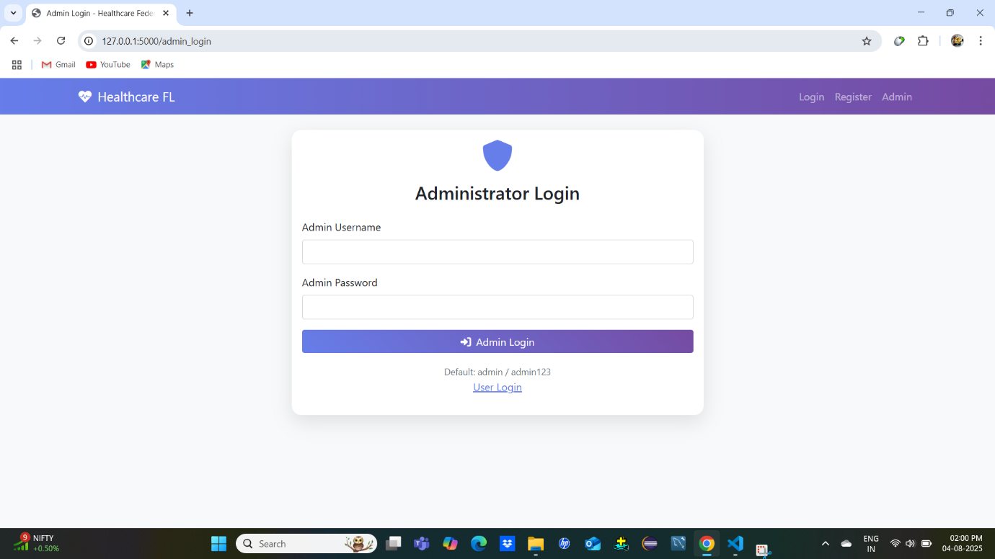
Fig7.3.4- Administrator Login

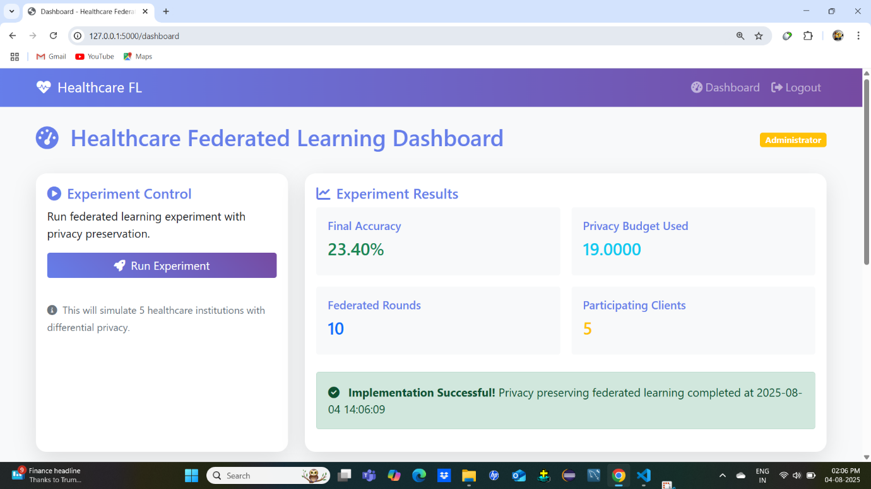
Fig 7.3.5- Experiment Result
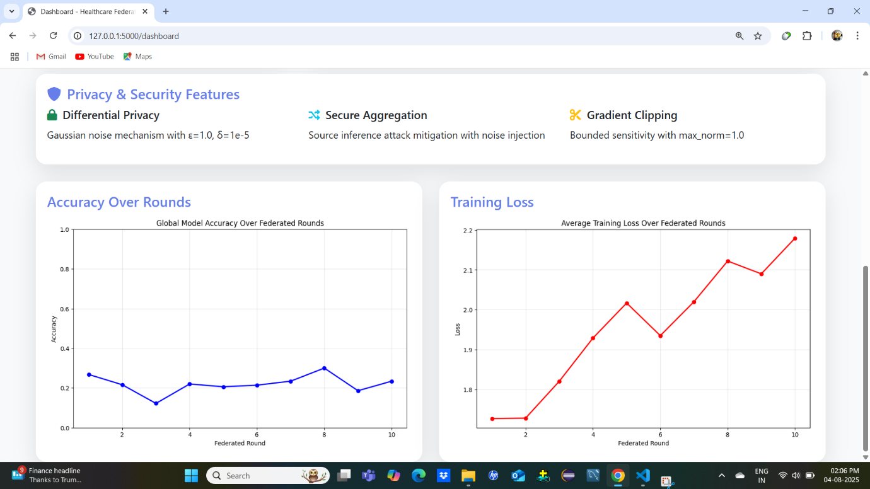 Fig:7.3.6- Accuracy Result

8.CONCLUSION
8.1: CONCLUSION:
In conclusion, Today, billions of people use wearable devices that collect a lot of health data. But this data is very private and cannot be easily shared. To solve this problem, the researchers created a system called FRESH. FRESH is a special framework that helps train AI models on health data without sharing the data directly. It uses a ring signature method to keep user identities secret and makes sure the data used is safe and correct. It also uses batch checking to speed up the process. The system was tested in many ways and showed good performance. In the future, the team plans to make it even better and use it in more areas of healthcare and other sensitive fields.
8.2 FUTURE ENHANCEMENT:
For future work, The FRESH framework has significant potential for future development and expansion. First, the system can be optimized to improve training speed, efficiency, and overall model performance, allowing real-time healthcare applications. Second, the framework can be extended beyond wearable data to include diverse medical domains such as imaging, electronic health records, and genomics, increasing its impact on diagnosis and treatment planning. Third, the architecture can be adapted for use in other sensitive sectors such as finance, education, and defense, where privacy-preserving collaborative learning is equally critical. Fourth, future versions can support more complex health data types like time-series, multimodal imaging, and unstructured clinical notes to improve the predictive capabilities of the model. Finally, enhancements will focus on making the system highly scalable and adaptive to real-world conditions, enabling seamless integration into large-scale smart healthcare ecosystems and multi-institutional collaborations.

9.REFERENCES
- S. Abhishek, M. Rajalakshmi, K. Naga Ravi, R. Siva Kumar, A. Kavitha, and P. Vamsi Krishna, "A Privacy Preserving Framework for Federated Learning in Smart Healthcare Systems," Information Processing & Management, 2023.
- McMahan, H.B., Moore, E., Ramage, D., Hampson, S., & y Arcas, B.A. (2017). "Communication-Efficient Learning of Deep Networks from Decentralized Data." Artificial Intelligence and Statistics, 1273–1282.
- Bonawitz, K., et al. (2017). "Practical Secure Aggregation for Privacy-Preserving Machine Learning." Proceedings of the 2017 ACM SIGSAC Conference on Computer and Communications Security, 1175–1191.
- Rivest, R. L., Shamir, A., & Tauman, Y. (2001). "How to Leak a Secret." ASIACRYPT 2001.
- Schnorr, C. P. (1991). "Efficient Signature Generation by Smart Cards." Journal of Cryptology.
- Latifah, L., et al. (2020). "Heart Disease Classification using Logistic Regression and Random Forests." International Journal of Advanced Computer Science.
- Saranya, S., & Asha, A. (2019). "Big Data Analytics in Healthcare – An Overview." International Journal of Scientific Research in Computer Science.
- Polap, D., & Woźniak, M. (2021). "Swarm Intelligence for Federated Learning in Medical Image Classification." Neural Computing and Applications.
- Yang, Q., Liu, Y., Chen, T., & Tong, Y. (2019). "Federated Machine Learning: Concept and Applications." ACM TIST.
- Mothukuri, V., Parizi, R. M., Pouriyeh, S., Huang, Y., Dehghantanha, A., & Srivastava, G. (2021). "A Survey on Security and Privacy of Federated Learning." Future Generation Computer Systems.
- Liu, Y., et al. (2021). "Analyzing Gradient Leakage and Defense Mechanisms in Federated Learning." IEEE Transactions on Dependable and Secure Computing.
- Sheller, M. J., et al. (2020). "Multi-institutional Deep Learning Modeling Without Sharing Patient Data: Federated Learning in Healthcare." Scientific Reports.
- Nguyen, D. C., et al. (2022). "Federated Learning for Smart Healthcare: A Survey." ACM Computing Surveys.
- Abouelmehdi, K., Beni-Hssane, A., Khaloufi, H., & Saadi, M. (2017). "Big Data Security and Privacy in Healthcare: A Review." Procedia Computer Science, 113, 73–80.
- Dwork, C. (2008). "Differential Privacy: A Survey of Results." International Conference on Theory and Applications of Models of Computation, 1–19.
- Shokri, R., & Shmatikov, V. (2015). "Privacy-Preserving Deep Learning." Proceedings of the 22nd ACM SIGSAC Conference on Computer and Communications Security, 1310–1321.

